Altering Photos
IN-CLASS ASSIGNMENT

Now you are going to take the new digital editing skills you just learned and apply them to the work of other photographers. Then you will analyze the effect your changes had on the photo.
DIRECTIONS:
-Find 8 examples of interesting photography from the internet.
-Make sure the images are a minimum of 300 pixels wide.
-Use PHOTOGRAPHS- not drawings, paintings, etc.
-Copy each image into this document in its ORIGINAL STATE.
-Then copy it into iPhoto and ALTER it using AT LEAST THREE of the methods below.
-You may also use OTHER methods in iPhoto that are not listed!
-Don’t just use the same alterations on every photo.
-Copy the altered image into this document, directly BELOW the original.
-Make sure the images are at size where they can be seen clearly in this document and are school appropriate.
-Below the photos, briefly list what you did to alter them and how you think it changed the photo. As you type/edit, make sure the text stays directly below the image and
on the SAME page.

T Y P E S O F A L T E R A T I O N :

-ROTATE: Rotate a photo to an angle different from the normal view.

-TILT: Use the “Straighten” tool to dramatically tilt the viewpoint of the photo.

-CROP: Crop the photo in an interesting and obvious way.

-RETOUCH: Use this tool to create a distorted version of a photo.

-BLACK&WHITE: Turn a color photo into black/white.

-SATURATED: Raise the saturation level to create very vibrant colors.

-EXPOSURE: Drastically raise or lower the level of exposure.

-TEMPERATURE: Modify the colors to a much warmer or cooler version.

Good starting points for photos:
http://photography.nationalgeographic.com/photography/
http://lightbox.time.com/

Save this file on your laptop in the following format:
[CLASS HOUR]_Altering_Photos_[YOUR LAST NAME, FIRST INITIAL].docx
Example: “1_Altering_Photos_SmithJ.docx”
EMAIL it to your teacher when complete (Subject should same format as file name)
EXAMPLE:
__________________________________________________________________________________
IMAGE:

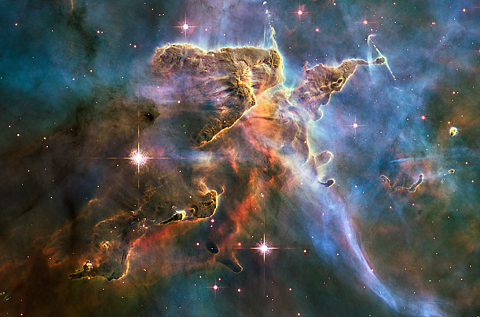

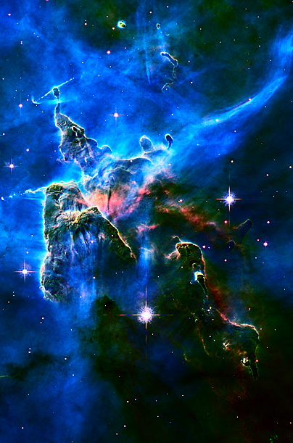
1- What specific ALTERATIONS did you make to this photo? (At least 3)
Rotate, Saturation, Contrast, and Temperature
2- How did your alterations CHANGE the effect of photo (MOOD, CENTER OF INTEREST, COMPOSITION, ETC.)?
It made it more dramatic and mysterious. The center of interest seems to be the pointy clouds, instead of the big star.

__________________________________________________________________________________
IMAGE 1:

(Highlight this text and Paste ORIGINAL image here. Resize if needed)

(Highlight this text and Paste YOUR ALTERED image here. Resize if needed)

1- What specific ALTERATIONS did you make to this photo? (At least 3)

2- How did your alterations CHANGE the effect of photo (MOOD, CENTER OF INTEREST, COMPOSITION, ETC.)?

__________________________________________________________________________________
IMAGE 2:

(Highlight this text and Paste ORIGINAL image here. Resize if needed)

(Highlight this text and Paste YOUR ALTERED image here. Resize if needed)

1- What specific ALTERATIONS did you make to this photo? (At least 3)

2- How did your alterations CHANGE the effect of photo (MOOD, CENTER OF INTEREST, COMPOSITION, ETC.)?

__________________________________________________________________________________
IMAGE 3:

(Highlight this text and Paste ORIGINAL image here. Resize if needed)

(Highlight this text and Paste YOUR ALTERED image here. Resize if needed)

1- What specific ALTERATIONS did you make to this photo? (At least 3)

2- How did your alterations CHANGE the effect of photo (MOOD, CENTER OF INTEREST, COMPOSITION, ETC.)?

__________________________________________________________________________________
IMAGE 4:

(Highlight this text and Paste ORIGINAL image here. Resize if needed)

(Highlight this text and Paste YOUR ALTERED image here. Resize if needed)

1- What specific ALTERATIONS did you make to this photo? (At least 3)

2- How did your alterations CHANGE the effect of photo (MOOD, CENTER OF INTEREST, COMPOSITION, ETC.)?

__________________________________________________________________________________
IMAGE 5:

(Highlight this text and Paste ORIGINAL image here. Resize if needed)

(Highlight this text and Paste YOUR ALTERED image here. Resize if needed)

1- What specific ALTERATIONS did you make to this photo? (At least 3)

2- How did your alterations CHANGE the effect of photo (MOOD, CENTER OF INTEREST, COMPOSITION, ETC.)?

__________________________________________________________________________________
IMAGE 6:

(Highlight this text and Paste ORIGINAL image here. Resize if needed)

(Highlight this text and Paste YOUR ALTERED image here. Resize if needed)

1- What specific ALTERATIONS did you make to this photo? (At least 3)

2- How did your alterations CHANGE the effect of photo (MOOD, CENTER OF INTEREST, COMPOSITION, ETC.)?

__________________________________________________________________________________
IMAGE 7:

(Highlight this text and Paste ORIGINAL image here. Resize if needed)

(Highlight this text and Paste YOUR ALTERED image here. Resize if needed)

1- What specific ALTERATIONS did you make to this photo? (At least 3)

2- How did your alterations CHANGE the effect of photo (MOOD, CENTER OF INTEREST, COMPOSITION, ETC.)?

__________________________________________________________________________________
IMAGE 8:

(Highlight this text and Paste ORIGINAL image here. Resize if needed)

(Highlight this text and Paste YOUR ALTERED image here. Resize if needed)

1- What specific ALTERATIONS did you make to this photo? (At least 3)

2- How did your alterations CHANGE the effect of photo (MOOD, CENTER OF INTEREST, COMPOSITION, ETC.)?

