Analyzing DEPTH of FIELD
IN-CLASS ASSIGNMENT
Depth of field is a powerful tool that you can use in your photography to control what the viewer focuses on. As you analyze how other photographers use this technique, think about how you could incorporate it into your work.

T Y P E S O F D E P T H O F F I E L D :

DEEP- Entire image is in-focus: SHALLOW (Foreground)- Only the closest objects are in-focus:
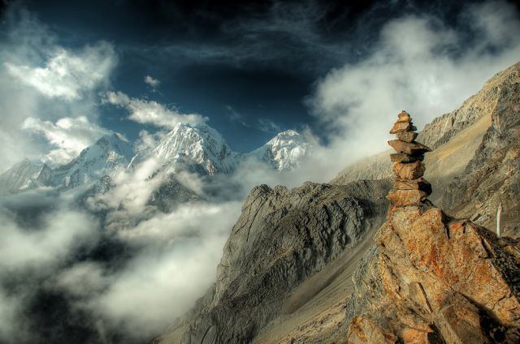

SHALLOW (Middle ground)- SHALLOW (Background)-
Only the objects BETWEEN foreground & Only the farthest away objects are in-focus
background are in-focus

DEEP Depth of Field = SMALLER APERTURE
SHALLOW Depth of Field = LARGER APERTURE

D I R E C T I O N S :
Correctly label the following photos and answer the questions about them with COMPLETE SENTENCES.

Save this file on your LAPTOP and EMAIL it to your teacher in the following format:
[CLASS HOUR] Analyzing Depth of Field [YOUR LAST NAME, FIRST INITIAL].docx
Example: “1 Analyzing Depth of Field Smith J.docx”

EXAMPLE:
___________________________________________________________________________________
Top of Form
Bottom of Form

- Which type of DEPTH of FIELD do you see in this photo (Deep, Shallow-Foreground, Shallow-Middle ground, or Shallow-Background)?
It is Shallow-Middle ground.
- What visual clues told you it was that Depth of Field?
The background is blurry and so is the shoulder of someone in the foreground, so that means only the middle ground is in-focus.
- Did the photographer probably use a LARGE or SMALL aperture for this photo?
They probably used a large aperture for a shallow depth of field.
- How does the use of Depth of Field enhance how you see this photo?
It makes the man stand out from the crowd, even though they are all wearing similar clothes.

___________________________________________________________________________________
IMAGE 1:
Top of Form
Bottom of Form

- Which type of DEPTH of FIELD do you see in this photo (Deep, Shallow-Foreground, Shallow-Middle ground, or Shallow-Background)?

- What visual clues told you it was that Depth of Field?

- Did the photographer probably use a LARGE or SMALL aperture for this photo?

- How does the use of Depth of Field enhance how you see this photo?

___________________________________________________________________________________
IMAGE 2:
Top of Form
Bottom of Form

- Which type of DEPTH of FIELD do you see in this photo (Deep, Shallow-Foreground, Shallow-Middle ground, or Shallow-Background)?

- What visual clues told you it was that Depth of Field?

- Did the photographer probably use a LARGE or SMALL aperture for this photo?

- How does the use of Depth of Field enhance how you see this photo?

___________________________________________________________________________________
IMAGE 3:
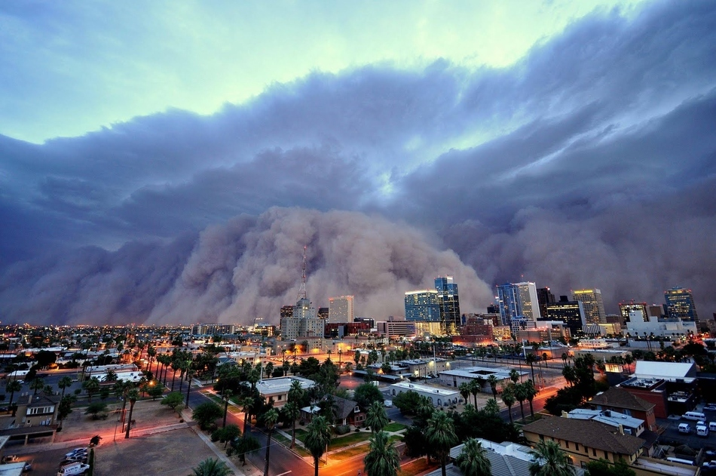
Top of Form
Bottom of Form

- Which type of DEPTH of FIELD do you see in this photo (Deep, Shallow-Foreground, Shallow-Middle ground, or Shallow-Background)?

- What visual clues told you it was that Depth of Field?

- Did the photographer probably use a LARGE or SMALL aperture for this photo?

- How does the use of Depth of Field enhance how you see this photo?

___________________________________________________________________________________
IMAGE 4:
Top of Form
Bottom of Form

- Which type of DEPTH of FIELD do you see in this photo (Deep, Shallow-Foreground, Shallow-Middle ground, or Shallow-Background)?

- What visual clues told you it was that Depth of Field?

- Did the photographer probably use a LARGE or SMALL aperture for this photo?

- How does the use of Depth of Field enhance how you see this photo?

___________________________________________________________________________________
IMAGE 5:
Top of Form
Bottom of Form

- Which type of DEPTH of FIELD do you see in this photo (Deep, Shallow-Foreground, Shallow-Middle ground, or Shallow-Background)?

- What visual clues told you it was that Depth of Field?

- Did the photographer probably use a LARGE or SMALL aperture for this photo?

- How does the use of Depth of Field enhance how you see this photo?

___________________________________________________________________________________
IMAGE 6:
Top of Form
Bottom of Form

- Which type of DEPTH of FIELD do you see in this photo (Deep, Shallow-Foreground, Shallow-Middle ground, or Shallow-Background)?

- What visual clues told you it was that Depth of Field?

- Did the photographer probably use a LARGE or SMALL aperture for this photo?

- How does the use of Depth of Field enhance how you see this photo?

___________________________________________________________________________________
IMAGE 7:
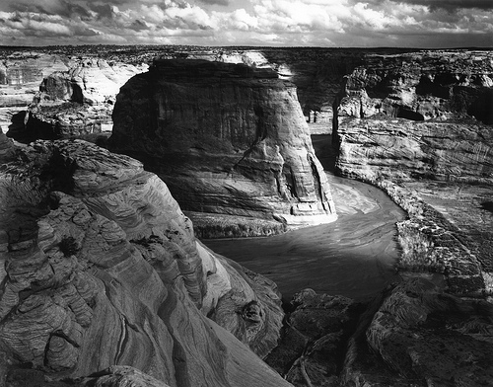
Top of Form
Bottom of Form

- Which type of DEPTH of FIELD do you see in this photo (Deep, Shallow-Foreground, Shallow-Middle ground, or Shallow-Background)?

- What visual clues told you it was that Depth of Field?

- Did the photographer probably use a LARGE or SMALL aperture for this photo?

- How does the use of Depth of Field enhance how you see this photo?

___________________________________________________________________________________
IMAGE 8:
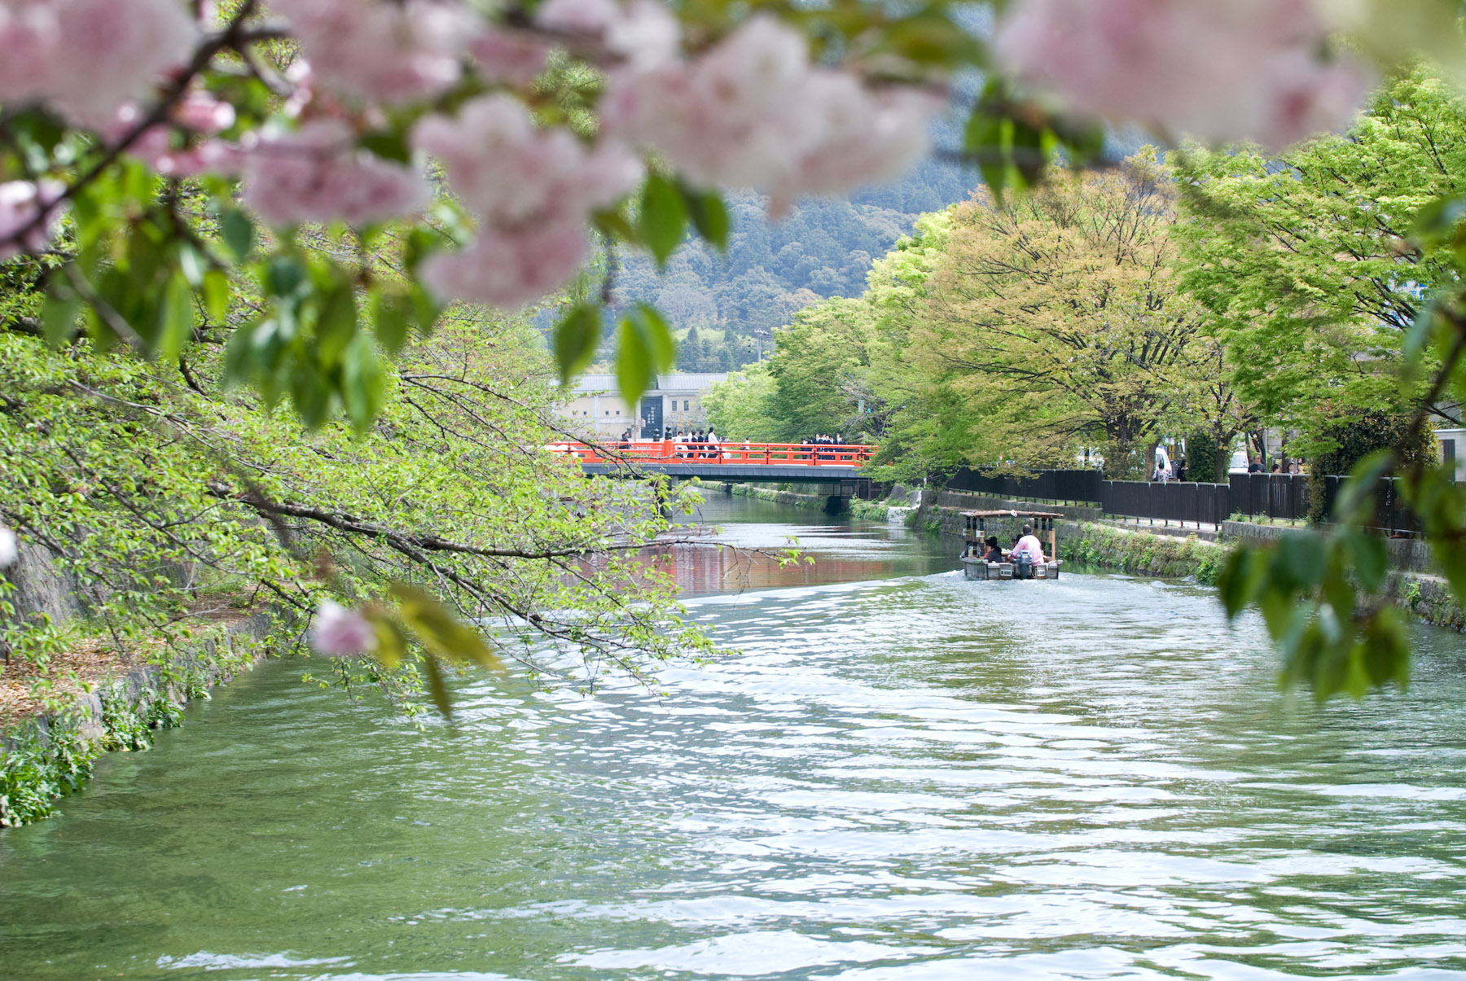
Top of Form
Bottom of Form

- Which type of DEPTH of FIELD do you see in this photo (Deep, Shallow-Foreground, Shallow-Middle ground, or Shallow-Background)?

- What visual clues told you it was that Depth of Field?

- Did the photographer probably use a LARGE or SMALL aperture for this photo?

- How does the use of Depth of Field enhance how you see this photo?

