Digital LIGHTING Effects
IN-CLASS ASSIGNMENT
While you will make most of the important choices concerning light with your camera, there are several digital lighting effects that can be applied afterwards with Photoshop. This lesson will give you a chance to explore them.

DIRECTIONS:
STEP 1- SOURCE IMAGES:
-Find at least 5 PHOTOS (either your own or from the internet) that you think might look interesting with lighting effects added to them. Images should be a minimum of 500 pixels wide. (If you are using your own photo, you might need to resize it before importing it into this document... ask you
teacher how to do this, if you don’t know.)
-Save them in a folder on your computer.
Good starting points:
http://photography.nationalgeographic.com/photography/
http://lightbox.time.com/

STEP 2- APPLYING LIGHTING EFFECTS:
-Open one of the photos in Photoshop.
-Click on FILTER---> RENDER---> LIGHTING EFFECTS to open up the Lighting Effects panel:
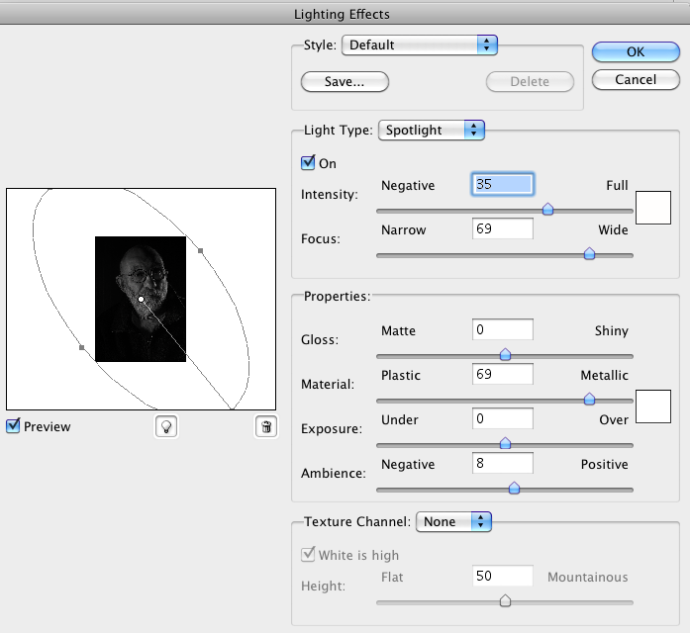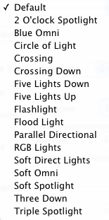

-NOTE: IF YOU DO NOT SEE “LIGHTING EFFECTS” LISTED, THEN YOU NEED TO RESTART PHOTOSHOP IN
32-BIT MODE (ASK YOUR TEACHER HOW TO DO THIS).
-Click on STYLE to see a list of all the different lighting effects you can apply to your image.
-Experiment with a few of them
-Once you find one you like, tweak it by adjusting the other settings on this panel.
-Click OK to commit your changes to the image.
-Remember you can always click EDIT--> UNDO, if you change your mind.

-Another (OPTIONAL) type of effect you can apply is a Lens Flare.
-Click on FILTER--> RENDER--> LENS FLARE to bring up this panel:

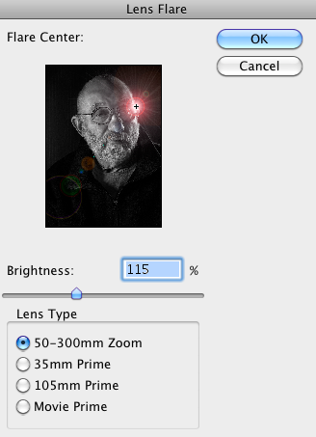

-You can click and drag the lens flare to the desired spot in your image and adjust its shape/intensity.
-Click OK to commit your changes.

STEP 3- SAVE AND REPEAT:
-As you finish adding lighting effects to your photo, click FILE--> SAVE AS... and add “LIGHTING1” to the
end of the filename (for example “JoePortrait.jpg” becomes “JoePortraitLIGHTING1.jpg”).
-Now open up the original, unaltered version again and apply a DIFFERENT LIGHTING EFFECT to it. Save it with another new name, as you did to the last one.
-You should end up with FOUR VERSIONS of each image... the original and 3 versions you added different
lighting effects to.
-Try to show a great deal of VARIETY in the different lighting effects you use.

STEP 4- ANALYZING IMPORTED IMAGES:
-Import ALL FOUR versions of each image (original and 3 new versions you created) into this
document below and answer the questions about them with COMPLETE SENTENCES.
-Make sure the images are next to each other and at size where they can be seen clearly in this document.
As you type/edit, make sure the questions stay directly below the images and on the SAME page.

Save this file on your LAPTOP in the following format and EMAIL it to your teacher:
[CLASS HOUR] Digital Lighting Effects [YOUR LAST NAME, FIRST INITIAL].doc
Example: “1 Digital Lighting Effects Smith J.doc”

EXAMPLE
___________________________________________________________________________________
IMAGE SET:

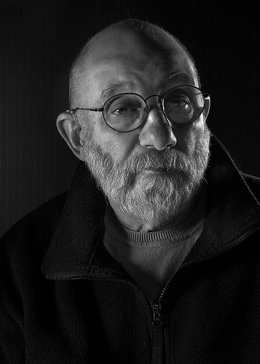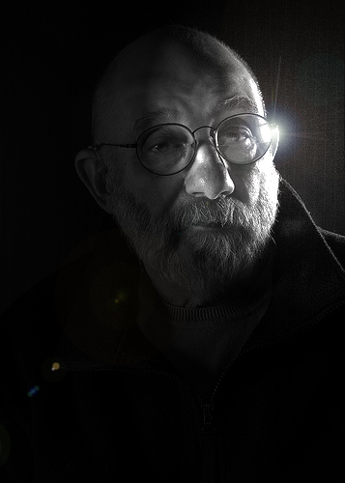

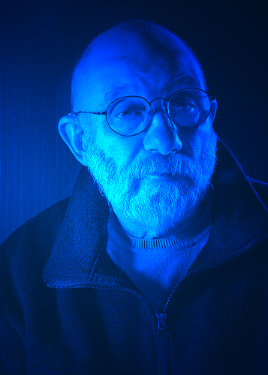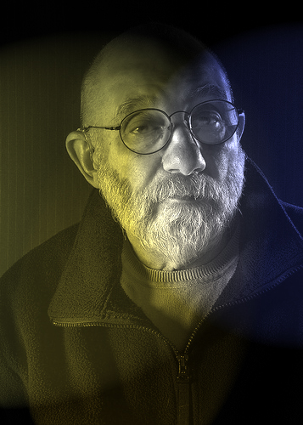

1- Describe the light in the ORIGINAL version (hard, soft, low, transmitted, reflected, etc.):
The original features soft light from either two light sources or one with a reflector. It is also relatively low light.

2- Which of the four versions is the most VISUALLY STRIKING... and WHY?
The second one is the most striking, because the new composition puts everything very off-center and the lens flare helps it pop out a bit more.

3- Of the three you altered, in which one has the MOOD most been changed by the new lighting? HOW?
The mood in the third one is very different now... in that severe blue lighting the man now almost seems like a creepy scientist conducting experiments.

___________________________________________________________________________________
IMAGE SET 1:

(Highlight this text and INSERT images here. Resize if needed)

1- Describe the light in the ORIGINAL version (hard, soft, low, transmitted, reflected, etc.):

2- Which of the four versions is the most VISUALLY STRIKING... and WHY?

3- Of the three you altered, in which one has the MOOD most been changed by the new lighting? HOW?

___________________________________________________________________________________
IMAGE SET 2:

(Highlight this text and INSERT images here. Resize if needed)

1- Describe the light in the ORIGINAL version (hard, soft, low, transmitted, reflected, etc.):

2- Which of the four versions is the most VISUALLY STRIKING... and WHY?

3- Of the three you altered, in which one has the MOOD most been changed by the new lighting? HOW?

___________________________________________________________________________________
IMAGE SET 3:

(Highlight this text and INSERT images here. Resize if needed)

1- Describe the light in the ORIGINAL version (hard, soft, low, transmitted, reflected, etc.):

2- Which of the four versions is the most VISUALLY STRIKING... and WHY?

3- Of the three you altered, in which one has the MOOD most been changed by the new lighting? HOW?

___________________________________________________________________________________
IMAGE SET 4:

(Highlight this text and INSERT images here. Resize if needed)

1- Describe the light in the ORIGINAL version (hard, soft, low, transmitted, reflected, etc.):

2- Which of the four versions is the most VISUALLY STRIKING... and WHY?

3- Of the three you altered, in which one has the MOOD most been changed by the new lighting? HOW?

___________________________________________________________________________________
IMAGE SET 5:

(Highlight this text and INSERT images here. Resize if needed)

1- Describe the light in the ORIGINAL version (hard, soft, low, transmitted, reflected, etc.):

2- Which of the four versions is the most VISUALLY STRIKING... and WHY?

3- Of the three you altered, in which one has the MOOD most been changed by the new lighting? HOW?

