Emotional Content
OBJECTIVE: Many great photos evoke strong emotional responses when you see them. By examining why certain photos are like this, you can learn to include more emotional content in your own photography to make it more compelling to the viewer.

STEP 1: Examining Emotional Photos
DIRECTIONS: Look at the following photos and describe the emotions that come to mind when you see them. Be specific in describing HOW the photo achieves this (subject matter, color, light, cropping, etc).
__________________________________________________________________________________
IMAGE 1:
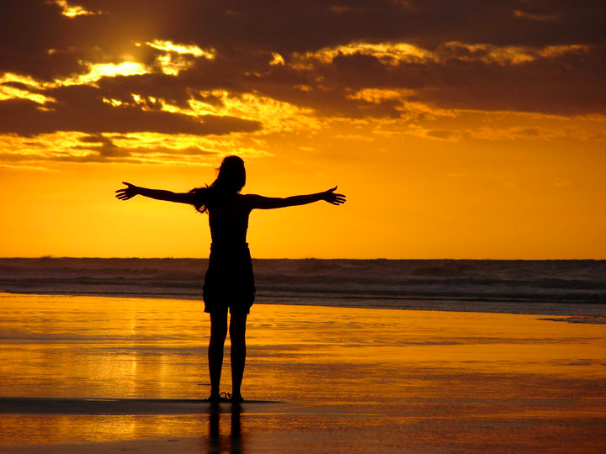

- What EMOTION or MOOD does this photo seem to have to you?
- What specific elements of the photo express this emotion?

__________________________________________________________________________________
IMAGE 2:

- What EMOTION or MOOD does this photo seem to have to you?
- What specific elements of the photo express this emotion?

__________________________________________________________________________________
IMAGE 3:

- What EMOTION or MOOD does this photo seem to have to you?
- What specific elements of the photo express this emotion?

STEP 2: Photo Scavenger Hunt
DIRECTIONS: Find 6 examples of photography (no drawings/paintings) from the internet that are strong examples of the requested EMOTION. DO NOT USE ANY PHOTOS OF HUMAN FACES (find other ways to show emotion). Copy each image into this document where directed. Make sure the images are at size where they can be seen clearly in this document and are SCHOOL APPROPRIATE. As you type/edit, make sure the text stays directly above the image and on the SAME page.

Good starting points:
http://photography.nationalgeographic.com/photography/
http://lightbox.time.com/

__________________________________________________________________________________
IMAGE 1: SADNESS

(Highlight this text and Paste PHOTO image here. Resize if needed)

__________________________________________________________________________________
IMAGE 2: HAPPINESS

(Highlight this text and Paste PHOTO image here. Resize if needed)

__________________________________________________________________________________
IMAGE 3: CALM

(Highlight this text and Paste PHOTO image here. Resize if needed)

__________________________________________________________________________________
IMAGE 4: EXCITEMENT

(Highlight this text and Paste PHOTO image here. Resize if needed)

__________________________________________________________________________________
IMAGE 5: FEAR

(Highlight this text and Paste PHOTO image here. Resize if needed)

__________________________________________________________________________________
IMAGE 6: HUMOR

(Highlight this text and Paste PHOTO image here. Resize if needed)

When you are finished, save this file to your computer and EMAIL it to your teacher in the following format:

[CLASS HOUR]_EmotionalContent_[YOUR LAST NAME, FIRST INITIAL].docx
Example: “1_EmotionalContent_SmithJ.docx”

