Examining Light
IN-CLASS ASSIGNMENT
To help you be more aware of how to use light in your photography, you will examine how experienced photographers work with it.

TYPES OF LIGHT IN PHOTOGRAPHY:

HARD LIGHT:
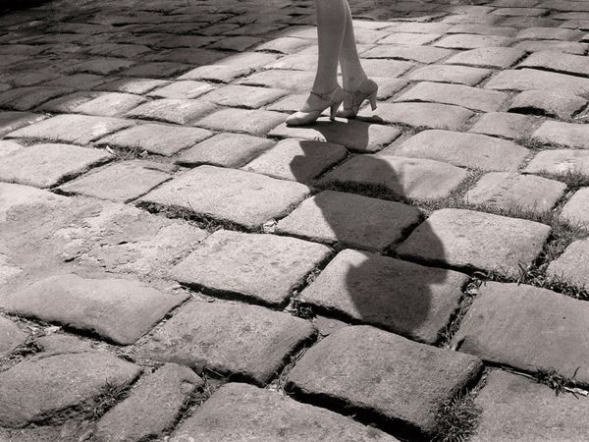
Caused by a bright, apparently small light source. Creates harsh shadows and strong highlights.
_________________________________________________________________________

SOFT LIGHT:
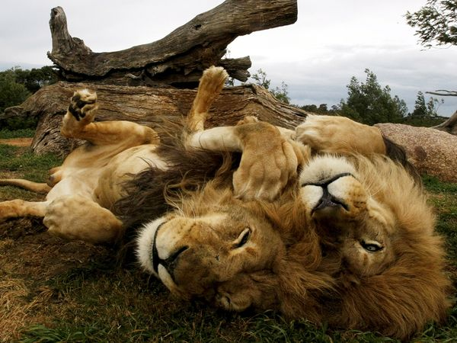
Caused by a large, diffused light source. Creates soft shadows and little/no highlights.

LOW LIGHT:
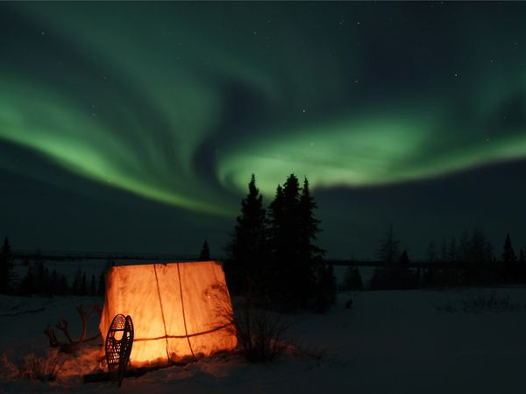
Caused when there is relatively little light in the image.
_________________________________________________________________________

TRANSMITTED LIGHT:
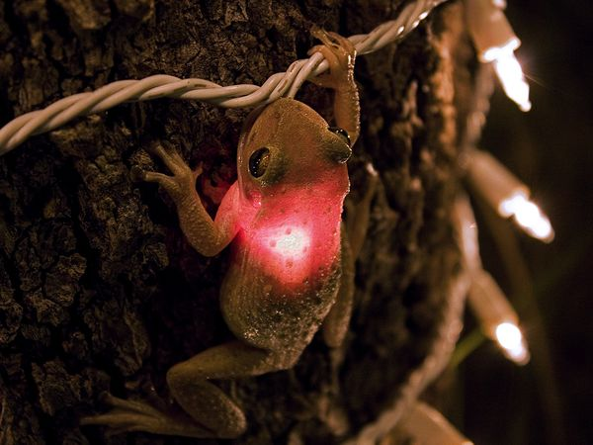
Means the light source(s) itself is visible in the image.
_________________________________________________________________________

REFLECTED LIGHT:
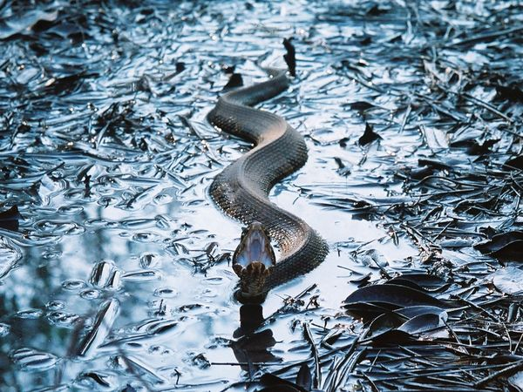
Light is indirectly seen in reflective surfaces or in bounced light on objects.

D I R E C T I O N S :
-Answer the questions about each of the following photos with COMPLETE SENTENCES.

Save this file on your LAPTOP in the following format and EMAIL it to your teacher:
[CLASS HOUR] Examining Light [YOUR LAST NAME, FIRST INITIAL].docx
Example: “1 Examining Light Smith J.docx”

EXAMPLE:
___________________________________________________________________________________
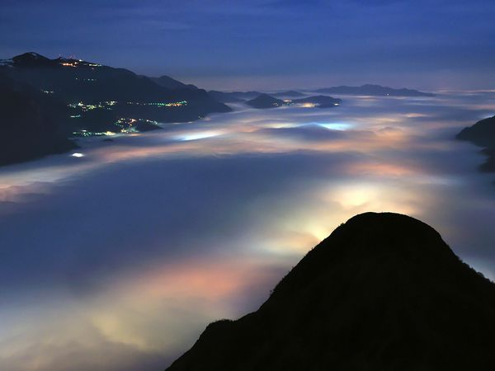

Top of Form
Type of LIGHT: | Describe which types of light you see in this photo:
HARD
SOFT
LOW | The photo is mostly dark, with some light from buildings and the city under the clouds.
TRANSMITTED | We can see the light sources- the buildings on the mountains and the city in the valley.
REFLECTED | The city lights are reflecting upon the clouds, creating large glowing areas.
Bottom of Form

- Describe how the use of LIGHT affects this photo (composition, focal point, texture, repetition, interest, etc.):
The use of light adds interest by creating an otherworldly image... it almost appears we are looking at lights underwater. The trails of city lights accentuate the texture of the clouds and lead our eyes through the picture.
- What might have been the most CHALLENGING thing about capturing this photo?
It would be difficult to capture all this detail in low light without camera noise or blurriness. This perspective might also have required some serious climbing on the part of the photographer.
- How does the use of light affect the MOOD of this photo?
It gives it a mysterious, yet peaceful quality.

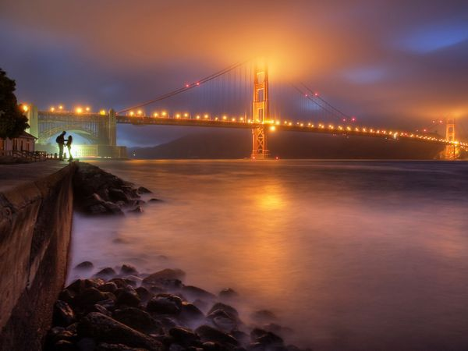
Top of Form
Type of LIGHT: | Describe which types of light you see in this photo:
HARD
SOFT
LOW
TRANSMITTED
REFLECTED
Bottom of Form

- Describe how the use of LIGHT affects this photo (composition, focal point, texture, repetition, interest, etc.):

- What might have been the most CHALLENGING thing about capturing this photo?

- How does the use of light affect the MOOD of this photo?

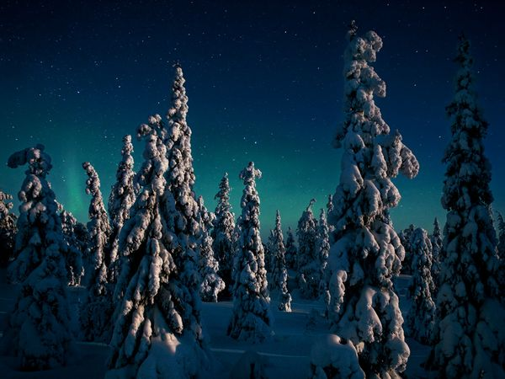
Top of Form
Type of LIGHT: | Describe which types of light you see in this photo:
HARD
SOFT
LOW
TRANSMITTED
REFLECTED
Bottom of Form

- Describe how the use of LIGHT affects this photo (composition, focal point, texture, repetition, interest, etc.):

- What might have been the most CHALLENGING thing about capturing this photo?

- How does the use of light affect the MOOD of this photo?

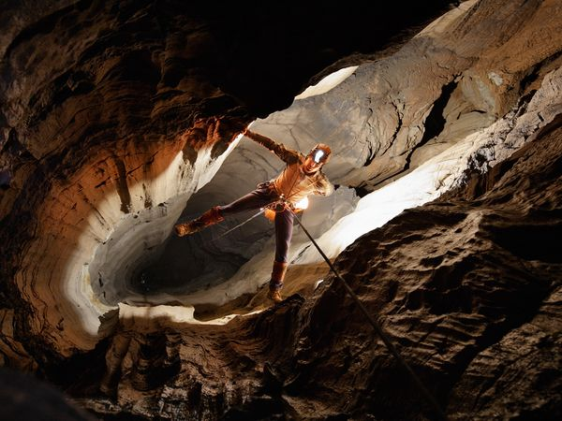
Top of Form
Type of LIGHT: | Describe which types of light you see in this photo:
HARD
SOFT
LOW
TRANSMITTED
REFLECTED
Bottom of Form

- Describe how the use of LIGHT affects this photo (composition, focal point, texture, repetition, interest, etc.):

- What might have been the most CHALLENGING thing about capturing this photo?

- How does the use of light affect the MOOD of this photo?

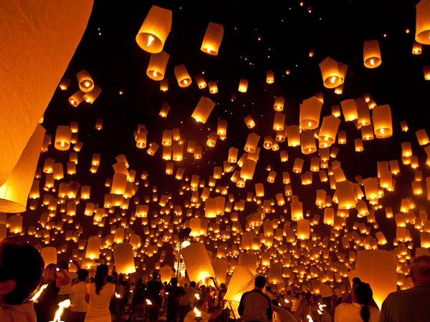
Top of Form
Type of LIGHT: | Describe which types of light you see in this photo:
HARD
SOFT
LOW
TRANSMITTED
REFLECTED
Bottom of Form

- Describe how the use of LIGHT affects this photo (composition, focal point, texture, repetition, interest, etc.):

- What might have been the most CHALLENGING thing about capturing this photo?

- How does the use of light affect the MOOD of this photo?

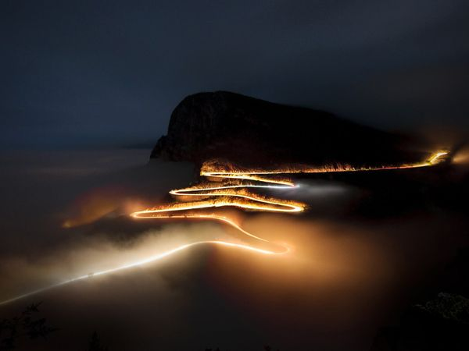
Top of Form
Type of LIGHT: | Describe which types of light you see in this photo:
HARD
SOFT
LOW
TRANSMITTED
REFLECTED
Bottom of Form

- Describe how the use of LIGHT affects this photo (composition, focal point, texture, repetition, interest, etc.):

- What might have been the most CHALLENGING thing about capturing this photo?

- How does the use of light affect the MOOD of this photo?

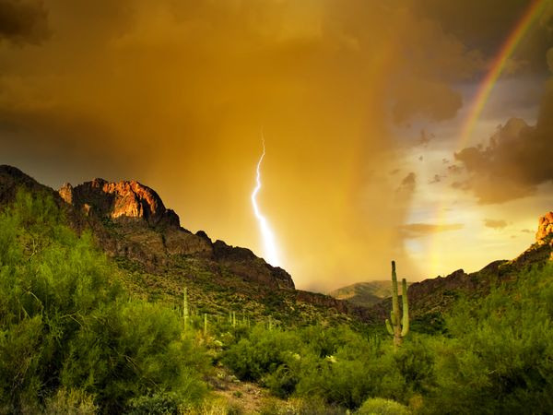
Top of Form
Type of LIGHT: | Describe which types of light you see in this photo:
HARD
SOFT
LOW
TRANSMITTED
REFLECTED
Bottom of Form

- Describe how the use of LIGHT affects this photo (composition, focal point, texture, repetition, interest, etc.):

- What might have been the most CHALLENGING thing about capturing this photo?

- How does the use of light affect the MOOD of this photo?

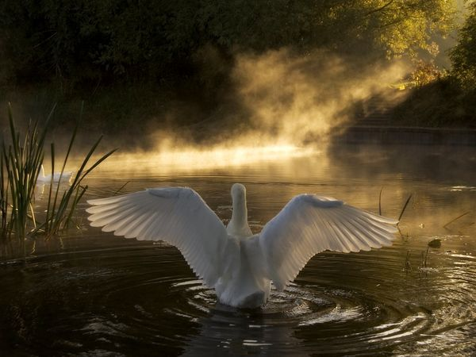
Top of Form
Type of LIGHT: | Describe which types of light you see in this photo:
HARD
SOFT
LOW
TRANSMITTED
REFLECTED
Bottom of Form

- Describe how the use of LIGHT affects this photo (composition, focal point, texture, repetition, interest, etc.):

- What might have been the most CHALLENGING thing about capturing this photo?

- How does the use of light affect the MOOD of this photo?

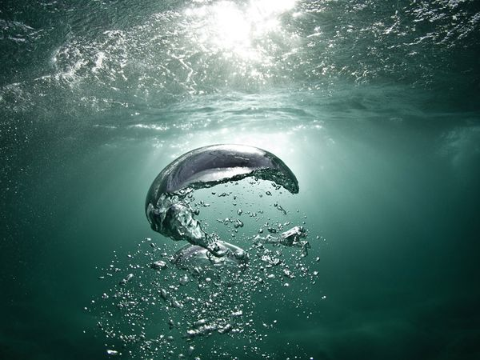
Top of Form
Type of LIGHT: | Describe which types of light you see in this photo:
HARD
SOFT
LOW
TRANSMITTED
REFLECTED
Bottom of Form

- Describe how the use of LIGHT affects this photo (composition, focal point, texture, repetition, interest, etc.):

- What might have been the most CHALLENGING thing about capturing this photo?

- How does the use of light affect the MOOD of this photo?

