LANDSCAPE CRITIQUE
In preparation for the landscape painting you are about to start, you will now look at some great work from the past (and present) in that genre. Answer all the questions below each photo thoughtfully and completely.

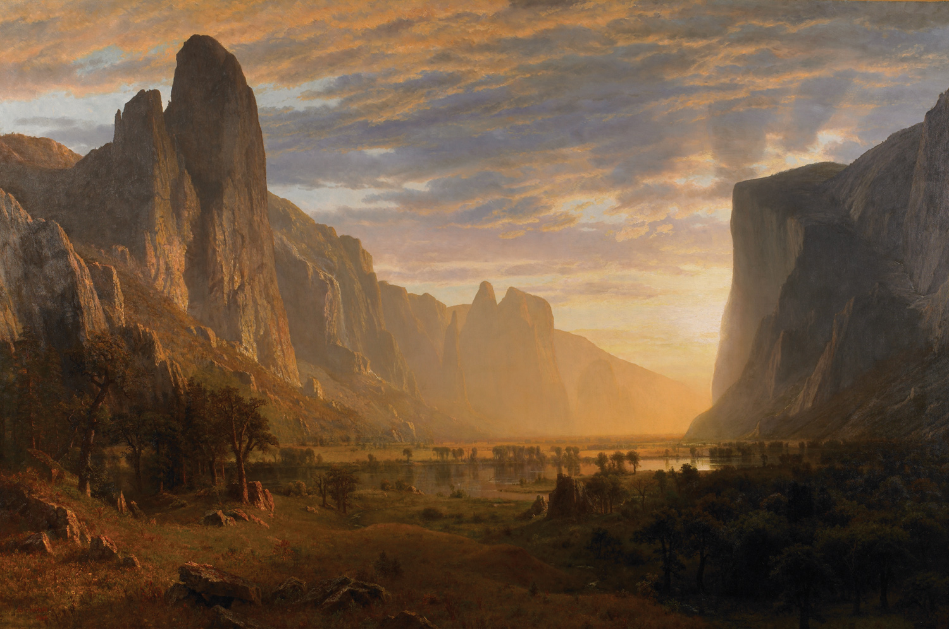

- What are THREE WORDS you would use to describe this landscape?

- Does this painting have a CENTER OF INTEREST? If so, where is it? If not, why not?

- Describe the use of COLOR in this painting. (For example... are the colors bold, muted, varied, similar, is one color or value dominant, etc.?)

- Describe the use of LIGHT in this painting. (Contrast, shadows, highlights, lighting effects, soft vs. hard light, reflections, etc.)

- Which MEDIUM would you guess this was painted with? (Watercolor, oil, acrylic, tempera, or digital)

- What might have been the HARDEST thing about painting this landscape?

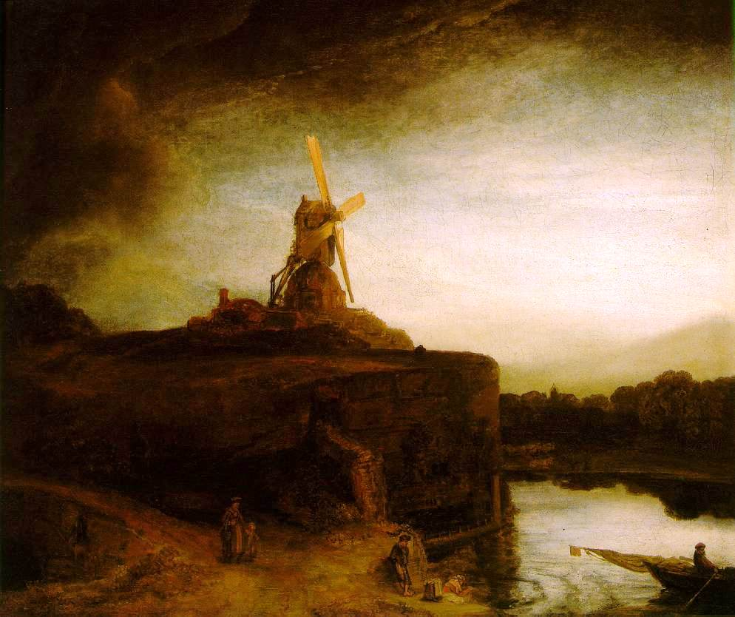

- What are THREE WORDS you would use to describe this landscape?

- Does this painting have a CENTER OF INTEREST? If so, where is it? If not, why not?

- Describe the use of COLOR in this painting. (For example... are the colors bold, muted, varied, similar, is one color or value dominant, etc.?)

- Describe the use of LIGHT in this painting. (Contrast, shadows, highlights, lighting effects, soft vs. hard light, reflections, etc.)

- Which MEDIUM would you guess this was painted with? (Watercolor, oil, acrylic, tempera, or digital)

- What might have been the HARDEST thing about painting this landscape?

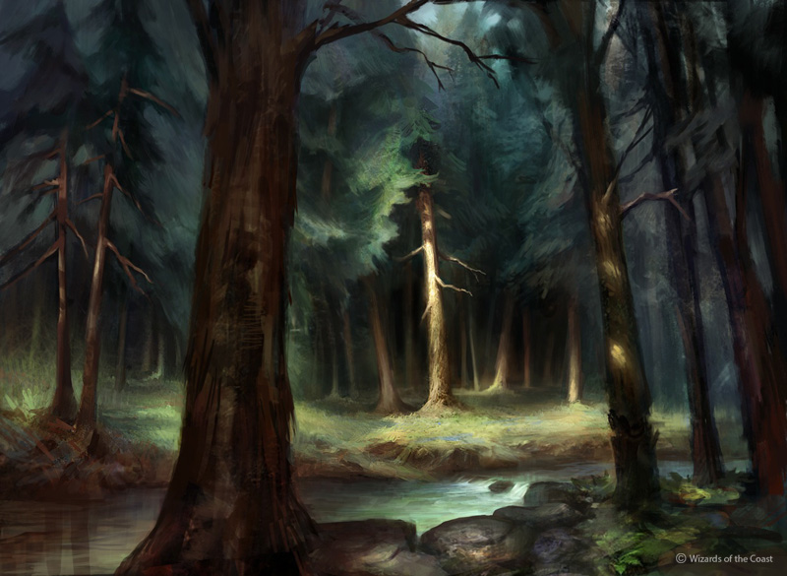

- What are THREE WORDS you would use to describe this landscape?

- Does this painting have a CENTER OF INTEREST? If so, where is it? If not, why not?

- Describe the use of COLOR in this painting. (For example... are the colors bold, muted, varied, similar, is one color or value dominant, etc.?)

- Describe the use of LIGHT in this painting. (Contrast, shadows, highlights, lighting effects, soft vs. hard light, reflections, etc.)

- Which MEDIUM would you guess this was painted with? (Watercolor, oil, acrylic, tempera, or digital)

- What might have been the HARDEST thing about painting this landscape?

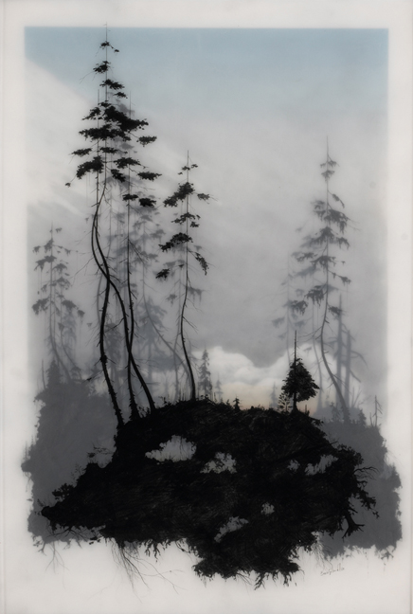

- What are THREE WORDS you would use to describe this landscape?

- Does this painting have a CENTER OF INTEREST? If so, where is it? If not, why not?

- Describe the use of COLOR in this painting. (For example... are the colors bold, muted, varied, similar, is one color or value dominant, etc.?)

- Describe the use of LIGHT in this painting. (Contrast, shadows, highlights, lighting effects, soft vs. hard light, reflections, etc.)

- Which MEDIUM would you guess this was painted with? (Watercolor, oil, acrylic, tempera, digital, etc.)

- What might have been the HARDEST thing about painting this landscape?

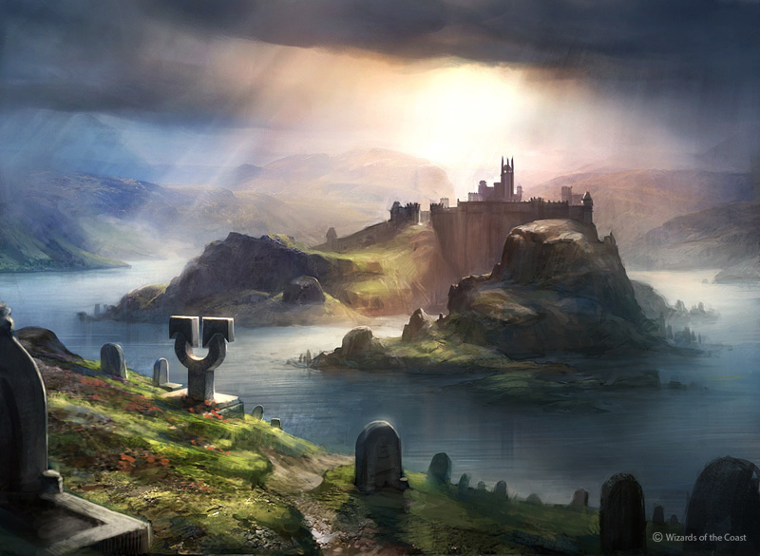

- What are THREE WORDS you would use to describe this landscape?

- Does this painting have a CENTER OF INTEREST? If so, where is it? If not, why not?

- Describe the use of COLOR in this painting. (For example... are the colors bold, muted, varied, similar, is one color or value dominant, etc.?)

- Describe the use of LIGHT in this painting. (Contrast, shadows, highlights, lighting effects, soft vs. hard light, reflections, etc.)

- Which MEDIUM would you guess this was painted with? (Watercolor, oil, acrylic, tempera, or digital)

- What might have been the HARDEST thing about painting this landscape?

Save this file on your laptop and
EMAIL it to your teacher when complete
(Subject of email should be: LANDSCAPE CRITIQUE)

