Removing Color
IN-CLASS ASSIGNMENT
One way to analyze color in photography is to remove it and look at the impact that has on the photo. Sometimes selectively leaving only one color can add impact, too. You will experiment with both in this assignment and analyze the results.

DIRECTIONS:
STEP 1- SOURCE IMAGES:
-Find at least 5 COLORFUL PHOTOS from the internet that you think might look interesting in BLACK &
WHITE.
-Save them in a folder on your computer.
Good starting points:
http://photography.nationalgeographic.com/photography/
http://lightbox.time.com/

STEP 2- CONVERTING TO BLACK/WHITE:
-Open one of the photos in Photoshop.
-Immediately click on “Save As...” and save it with “BW” added to the end of the filename.
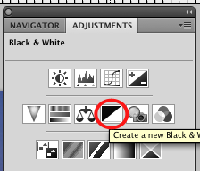
(For example: “Image01.jpg” would become “Image01BW.jpg”)
-Click on “Window” and then “Adjustments” to bring up this panel ------>
-Click on the symbol in the red circle to create a Black & White
Adjustment Layer.
-FLATTEN and SAVE the image.

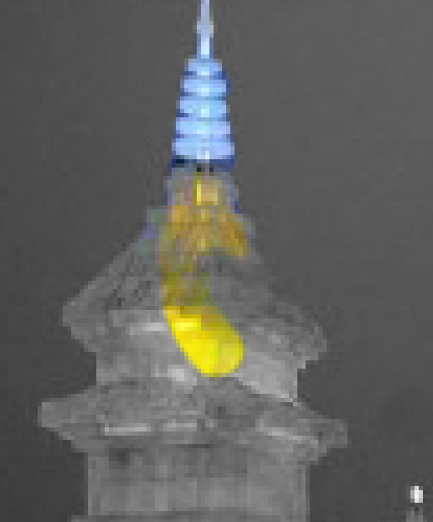

STEP 3- SELECTIVE COLOR:
-Click on “Edit” and then “Undo” to undo the flattening of the image
-Decide on ONE AREA or object to LEAVE colored
<---------Select the BRUSH tool, set your Foreground Color to BLACK, and carefully
draw on the Adjustment Layer over that area. Zoom in and adjust the
size of the brush, if you need to.
-If you mess up, switch the brush color to WHITE to patch it up
-When done, FLATTEN the image.
-Click on “Save As...” and save it with “SELECTIVE” added to the end
(“Image01.jpg” would become “Image01 SELECTIVE.jpg”)

STEP 4- ANALYZING IMPORTED IMAGES:
-Import each of the three versions of each image (original, black/white, selective color) into THIS
DOCUMENT below and ANSWER the questions about them with COMPLETE SENTENCES.
-Make sure the images are next to each other and at size where they can be seen clearly in this document.
As you type/edit, make sure the questions stay directly below the images and on the SAME page.

Save this file on your LAPTOP and EMAIL it to your teacher in the following format:
[CLASS HOUR]_RemovingColor_[YOUR LAST NAME, FIRST INITIAL].docx
Example: “1_RemovingColor_SmithJ.docx”

EXAMPLE
___________________________________________________________________________________
IMAGE SET:

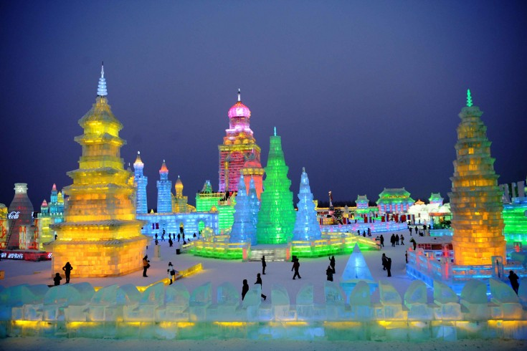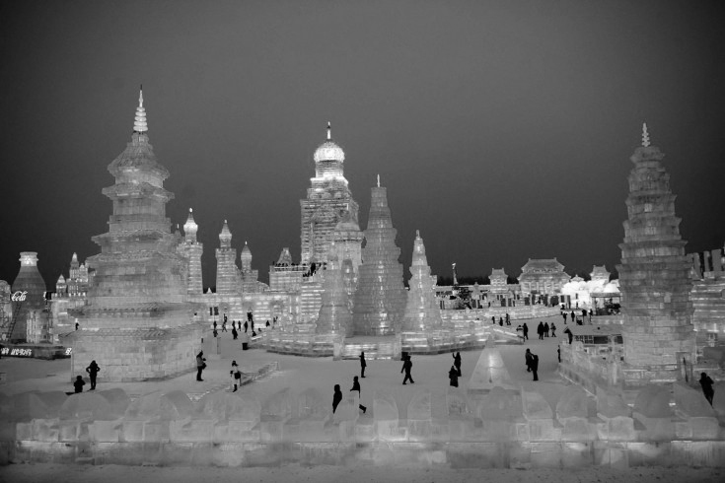

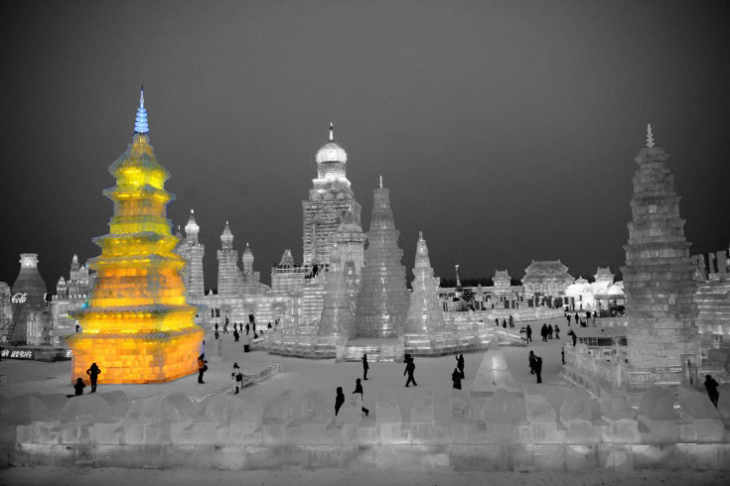
1- How did the photographer use color in the ORIGINAL photo to add interest (contrast, boldness, repetition, focal point, etc.)?
The wide variety of colors makes the ice sculptures stand out more. There is no one focal point.

2- Describe how removing all color changed the picture (mood, composition, focal point, etc.):
It made the brightest lights and the dark people stand out more.

3- In the black/white version is there a strong range of values or does everything mostly blend together?
There is a good range from the very bright lights, to the dark sky, to the black silhouettes of people.

4- What effect does selectively leaving one area of color have on the photo?
Now there is definitely one center of interest. And it is off-center, which makes the composition more interesting.

5- Which of the three photos appeals to you the most and WHY?
The third is the most appealing, because it is so unique.

___________________________________________________________________________________
IMAGE SET 1:

(Highlight this text and INSERT images here. Resize if needed)

1- How did the photographer use color in the ORIGINAL photo to add interest (contrast, boldness, repetition, focal point, etc.)?

2- Describe how removing all color changed the picture (mood, composition, focal point, etc.):

3- In the black/white version is there a strong range of values or does everything mostly blend together?

4- What effect does selectively leaving one area of color have on the photo?

5- Which of the three photos appeals to you the most and WHY?

___________________________________________________________________________________
IMAGE SET 2:

(Highlight this text and INSERT images here. Resize if needed)

1- How did the photographer use color in the ORIGINAL photo to add interest (contrast, boldness, repetition, focal point, etc.)?

2- Describe how removing all color changed the picture (mood, composition, focal point, etc.):

3- In the black/white version is there a strong range of values or does everything mostly blend together?

4- What effect does selectively leaving one area of color have on the photo?

5- Which of the three photos appeals to you the most and WHY?

___________________________________________________________________________________
IMAGE SET 3:

(Highlight this text and INSERT images here. Resize if needed)

1- How did the photographer use color in the ORIGINAL photo to add interest (contrast, boldness, repetition, focal point, etc.)?

2- Describe how removing all color changed the picture (mood, composition, focal point, etc.):

3- In the black/white version is there a strong range of values or does everything mostly blend together?

4- What effect does selectively leaving one area of color have on the photo?

5- Which of the three photos appeals to you the most and WHY?

___________________________________________________________________________________
IMAGE SET 4:

(Highlight this text and INSERT images here. Resize if needed)

1- How did the photographer use color in the ORIGINAL photo to add interest (contrast, boldness, repetition, focal point, etc.)?

2- Describe how removing all color changed the picture (mood, composition, focal point, etc.):

3- In the black/white version is there a strong range of values or does everything mostly blend together?

4- What effect does selectively leaving one area of color have on the photo?

5- Which of the three photos appeals to you the most and WHY?

___________________________________________________________________________________
IMAGE SET 5:

(Highlight this text and INSERT images here. Resize if needed)

1- How did the photographer use color in the ORIGINAL photo to add interest (contrast, boldness, repetition, focal point, etc.)?

2- Describe how removing all color changed the picture (mood, composition, focal point, etc.):

3- In the black/white version is there a strong range of values or does everything mostly blend together?

4- What effect does selectively leaving one area of color have on the photo?

5- Which of the three photos appeals to you the most and WHY?

